7.43: The initial and final kinetic energies are both zero, so the work done by the spring is the negative of the work done by friction, or 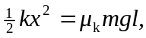 where l is the distance the block moves. Solving for 